Technical Note

Subject: How to integrate SIMEAS P50 power meter into PecStar

Step 1: Install the AnyPolling driver
- Copy the driver files to your local machine.
– DrvAnyPolling.dat
– AnyPollingMeter.dat
- Run DeviceInstall.exe under the \Common folder of PecStar iEMS (for example, \CET\iEMS\Common) to install the driver.
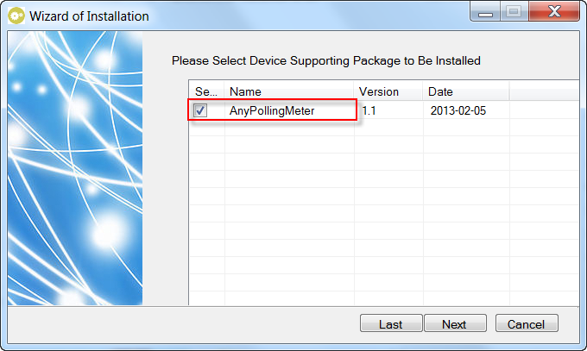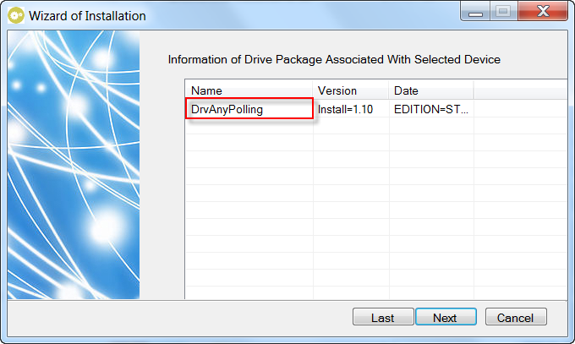
- Quit DeviceInstall after the driver is installed.
Step 2: Configure the device
- Start PecConfig.
- Add a site. The Site Properties window appears as below.
Site Name: enter a name for the site.
Driver Type: select ‘Polling Protocol Master Site Driver’
Keep other settings as default.
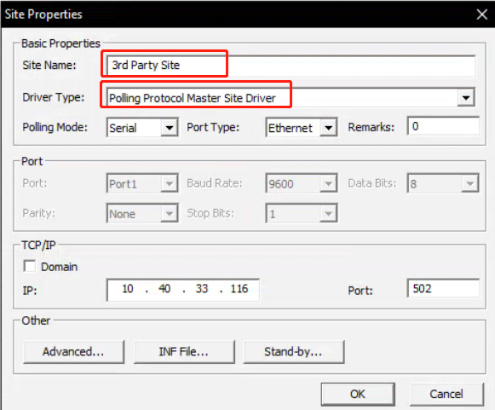
- Add a device. The Device Properties window appears as below.
Device Name: enter a name for the site.
Device Type: select ‘AnyPollingMeter’
Keep other settings as default.

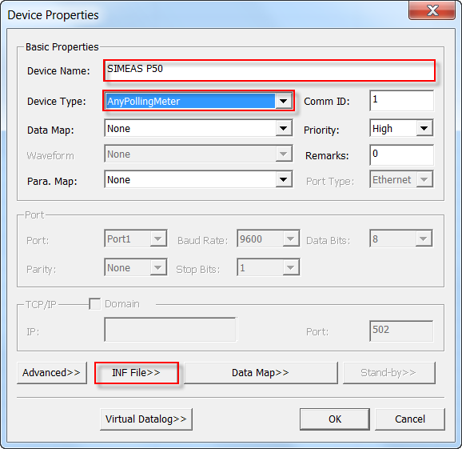
- Edit the INF file. In the Device Properties window, click the INF File>> button, copy the content from the txt file and paste it at the bottom of the inf file.
- Import the SNF file to the device. Create a SNF file according to the communication protocol document of the 3rd party device.
- Enable debugging if required. In the Device Properties window, click the Advanced>> button, check Show debug info. and Save debug info..
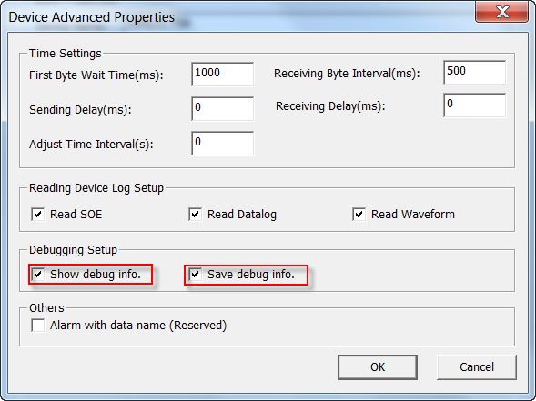
- Click the Save icon from the toolbar of PecConfig to save the configurations to database.

Step 3: Commissioning the communications with the device
